2021
BK8 Middle School Football Schedule
Day | Date | Opponent | Site | Time
Thursday | Aug. 26 | Jamboree | Vernon | TBA
Tuesday | Aug. 31 | Blountstown | HOME | 6:00
Tuesday | Sept. 7 | OPEN | ------ | ------
Tuesday | Sept. 14 | Liberty County | Away | 5:30 cst
Tuesday | Sept. 21 | Chipley | Away | 5:00
Tuesday | Sept. 28 | Vernon | HOME | 6:00
Tuesday | Oct. 5 | Grand Ridge | Away | 5:00
Tuesday | Oct. 12/14 | Championship | TBD | TBD

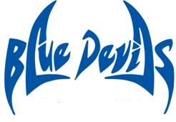
Coaches Principal
Brad Johnson Chey Bowers
Ryan Boyd
Kenny Tate / AD Assistant Principals Medea Callahan
Tiffany Steverson
Beverly Sallas
Updated: 8/10/2021

