2019
BK8 Middle School Football Schedule
Day | Date | Opponent | Site | Time
Thursday | Aug. 22 | Jamboree  Chipley vs. Bonifay (5:30)  Vernon vs. Grand Ridge (6:45) | Vernon | 5:30
Tuesday | Aug. 27 | Liberty Co. | Bristol, FL | 5:30 CST.
Tuesday | Sept. 3 | Blountstown | HOME | 6:00
Tuesday | Sept. 10 | Chipley | Chipley | 6:00
Tuesday | Sept. 17 | Vernon | HOME | 6:00
Tuesday | Sept. 24 | Marianna | HOME | 6:00
Tuesday | Oct. 1 | Grand Ridge | Grand Ridge | 6:00

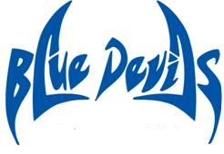
Coaches Principal
Brad Johnson Farica West
Kenny Tate Assistant Principals Chey Bowers / A.D.
Beverly Sallas
Tiffany Steverson
Updated: 8/13/2019

