2017
Bonifay K-8 Middle School Football Schedule
Day | Date | Opponent | Site | Time
Tuesday | Aug. 22 | (Jamboree)  Bonifay vs. Freeport | Vernon | 6:00
Tuesday | Aug. 29 | Chipley | Away | 5:30 / 6:30
Tuesday | Sept. 5 | Blountstown | HOME | 5:30 / 6:30
Thursday | Sept. 14 | Vernon  No “B” Team | HOME | 5:30 / 6:30
Tuesday | Sept. 19 | Graceville  No “B” Team | HOME | 6:30
Tuesday | Sept. 26 | Grand Ridge | Away | 5:30 / 6:30
Tuesday | Oct. 3 | Liberty County | Away | 6:00 / 7:00 E.T.
Tuesday | Oct. 10 | OPEN | Bye Week
Thursday | Oct. 17 | Playoffs | TBA | TBA
***B Team will begin at 5:30, A Team will follow***
**Note-The B team will scrimmage BLUE (Offense) vs. WHITE (Defense) on 9/14.**
**Note-There will not be a “B” game on 9/19.**
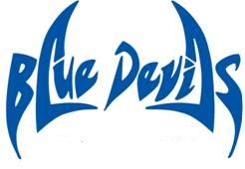
Coaches Principal
Brad Johnson Rodd Jones
Ryan Boyd Assistant Principals
Kenny Tate Chey Bowers / A.D.
Beverly Sallas
Updated: 9/15/2017

