2018
Bonifay K-8 Middle School Football Schedule
Day | Date | Opponent | Site | Time
Thursday | Aug. 23 | (Jamboree)  Bonifay vs. Liberty Co.  Bonifay vs. Roulhac | Vernon  1st Half  2nd Half | 6:00  6:30
Tuesday | Aug. 28 | Liberty County | HOME | 5:30 / 6:30
Tuesday | Sept. 4 | Blountstown | Away | 5:30 / 6:30
Tuesday | Sept. 11 | Chipley | HOME | 5:30 / 6:30
Tuesday | Sept. 18 | Vernon | HOME | 5:30 / 6:30
Tuesday | Sept. 25 | Grand Ridge  No “B” Team | HOME | 6:30  (A Team only)
Tuesday | Oct. 2 | Vernon | Away | 5:30 / 6:30
Tuesday | Oct. 9 | OPEN | Bye Week
Thursday | Oct. 18 | Playoffs | TBA | TBA
***B Team will begin at 5:30, A Team will follow***
**Note -- There will not be a “B” game on 9/25**
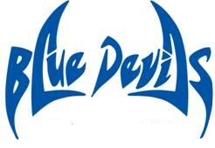
Coaches Principal
Brad Johnson Rodd Jones
Kenny Tate Assistant Principals
Chey Bowers / A.D.
Beverly Sallas
Updated: 9/12/2018

